EDRC Use Case 1, Test Case 1, Section 6.1.2 Item Number
Revision of EDRC doc:

11 | Updated to reflect comments from David Price | K Willshaw  30 March 2015

Test case spec release 1.0

6.1.2 Item Number
This is the identifier of the pump, commonly referred to as the Tag Number and as described in section 5.7 is done by declaring the object and assigning its identity class and string

Define Object (ClassificationOfIndividual)
Role  No | Role Name | Role Type | Example
1 | hasClassified | PossibleIndividual | Uuid of Pump
2 | hasClassifier | ClassOfIndividual | CENTRIFUGAL PUMP

Define Identification (ClassifiedIdentificationOfIndividual)

Role  No | Role Name | Role Type | Example
1 | hasIdentified | PossibleIndividual | Uuid of Pump established by of Pump Object
2 | valIdentfier | Express String | P-11100A
3 | hasIndentificationType | ClassOfClassOfIdentification | TAGGED OBJECT NAME ASSIGNMENT CLASS

Comment : valIdentifier role type is incorrect in this table, the template actually states (tpl:valIdentifier only xsd:string)
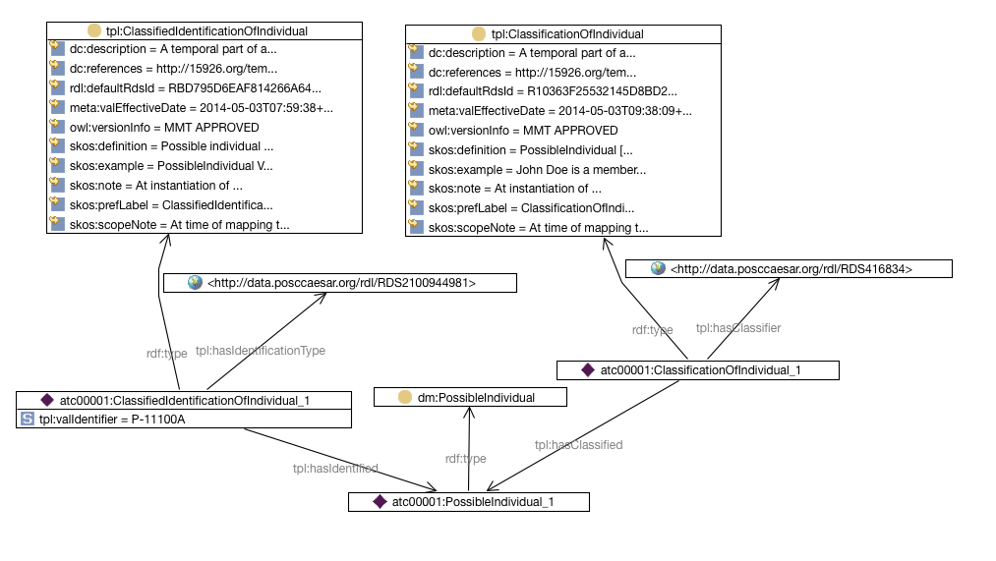
SPARQL to find Item Number of Pump

SELECT ?PumpIdentifier
WHERE {
?possibleindividual rdf:type dm:PossibleIndividual .
?classificationofindividual tpl:hasClassified ?possibleindividual .
?classificationofindividual tpl:hasClassifier <http://data.posccaesar.org/rdl/RDS416834> .
?classificationofindividual rdf:type tpl:ClassificationOfIndividual .
?classifiedidentificationofindividual tpl:hasIdentificationType <http://data.posccaesar.org/rdl/RDS2100944981> .
?classifiedidentificationofindividual tpl:hasIdentified ?possibleindividual .
?classifiedidentificationofindividual rdf:type tpl:ClassifiedIdentificationOfIndividual .
?classifiedidentificationofindividual tpl:valIdentifier ?PumpIdentifier .
}

